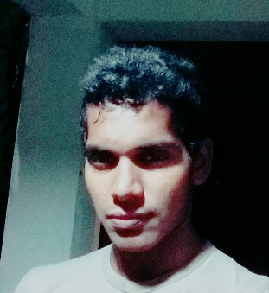

ABOUT ME

**Bushitha Sehan Geekiyanage**

I’m interested in making new things and even more inventing things better. specially in Hydraulic stream. I’ve been inventing thins since I was grade 5 the first invention was a Cob web breaker. After that creation, I supposed to turn for hydraulic side. With that I made a model of an excavator which was fully done by wood and working by syringes. After the first approach, I developed it to a level which is operated by manual wooden levers. With the time passes, a mature idea came to my mind to make a miniature excavator model with fully metal and worked by DC current. So, I successfully finished that project, when I was grade 11 at the school.

After the school life, with my own knowledge about hydraulics and the A/L physics knowledge, my mind said to invent an efficient Excavator machine for the world, as a solution for the increasing energy crisis which affects to the whole world. So, I spent my whole life, my efforts, attempts, time and my money for this significant thing. But most of the people said “this is never gonna work”. With these all barriers, I’ve done it successfully within 2 years of time.

With these, I feel like, I’m stick into this endevorous thing with my entire life to inventing more products and more invention which relates to Hydraulics and Heavy machinery for world and success of the all of us with this carrier.

**Education**

Did O/L (English medium) in Prince of Wales College Moratuwa (2000 to 2010)

Did A/L (Biology English medium) Taxila College (2011 to 2013)

**Higher Education**

Doing Mechanical Engineering in International College of Business and Technology Associated with Cardiff Metropolitan University

**Experience**

Two and half years experienced in Hydraulic machinery, tools, materials, welding, and all other stuff relates to industry

**What I can do**

Hydraulic system designing

Machinery Structural designing

Hydraulic Equipment manufacturing

Hydraulic system troubleshooting

Construction machinery maintenances